**CP Club 365 Days Challenge**

**Programming language – Python**

**Problem Statement**

<https://practice.geeksforgeeks.org/problems/majority-element-1587115620/0>

Git :- <https://github.com/Vedantbharad2603/CP_club_365_Days>

**Your Code**:

def majorityElement(self, A, N):

        #Your code here

        count=1

        res=0

        for i in range(1,N):

            if A[res]== A[i]:

                count+=1

            else:

                count-=1

            if count==0:

                count=1

                res=i

        count=0

        for i in range(0,N):

            if A[res]== A[i]:

                count+=1

        if count>(N/2):

            return A[res]

        return -1

**Output (Screen Shot)**:

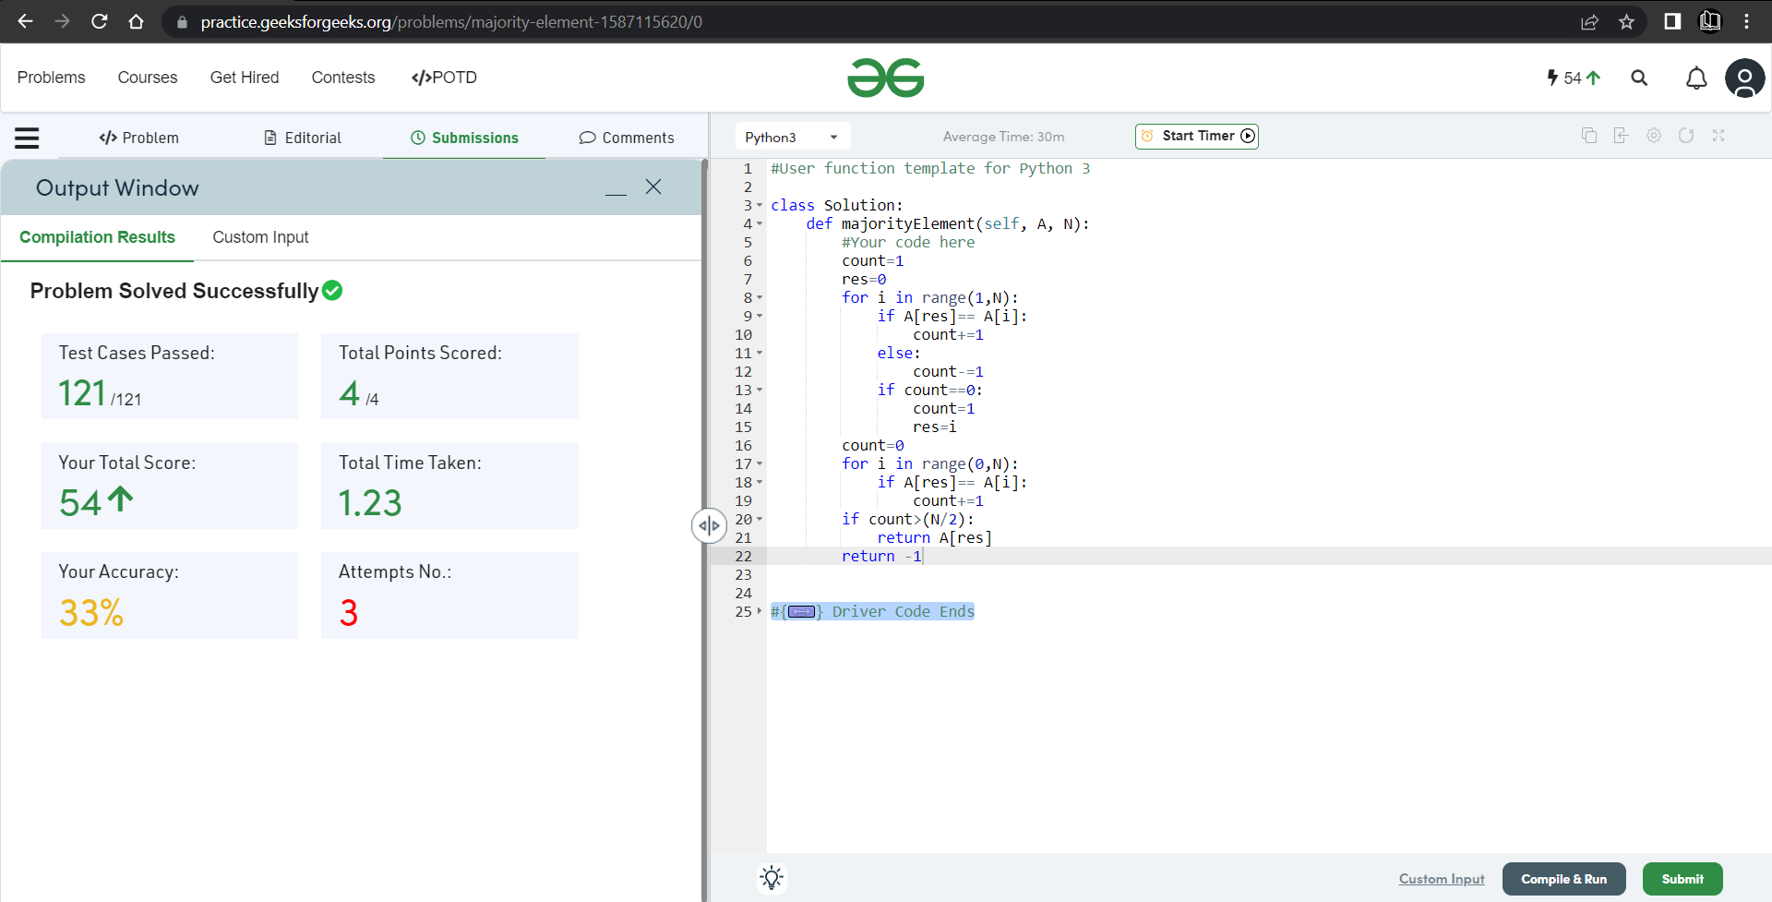

**Understanding about problem:**

* In this task I need to find number which is appears more then N/2 time and return that number if there is no any number found which is appears more then N/2 time then return -1.

Note: If you can't understand the problem, feel free to contact us and we'll help you. Please don't copy and paste from anywhere.

ALL THE BEST

Team CP Club